Develop a Learning From Incidents (LFI) culture that engages front line staff.

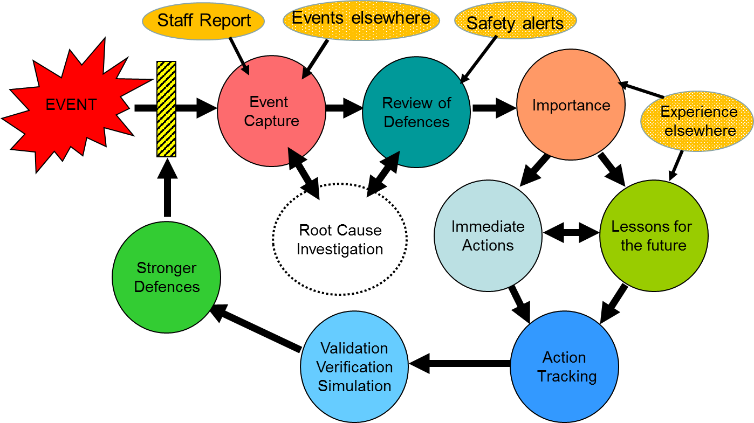

Lead Researchers:
Rob Miles
Lead Organisation: Hu-Tech Ltd
NHS Q Partner
Mary Jenkins: Frimley Health Foundation Trust
Summary
Implement a learning from incidents process to engage teams in developing improvements in paediatric care and prevent reoccurrence of unplanned and adverse events and embed a culture of continuous improvement.
Background
We all aspire to treat patients to improve their health so when things go wrong and a patient suffers avoidable harm it affects everyone. When patient safety incidents, Serious Reportable Incidents (SIRIs) or Never Events (NEs) occur the process of understanding and learning through investigation can soon lead to a breakdown in team working and peer support. This is especially damaging to everyone involved when the incident is a repeat of one that has happened before, and worst still, subject to an investigation, as is exposes a fundamental failure to learn from incidents. The challenge is that Learning From Incidents (LFI) is hard and requires a difference type of investigation combined with a high degree to trust.

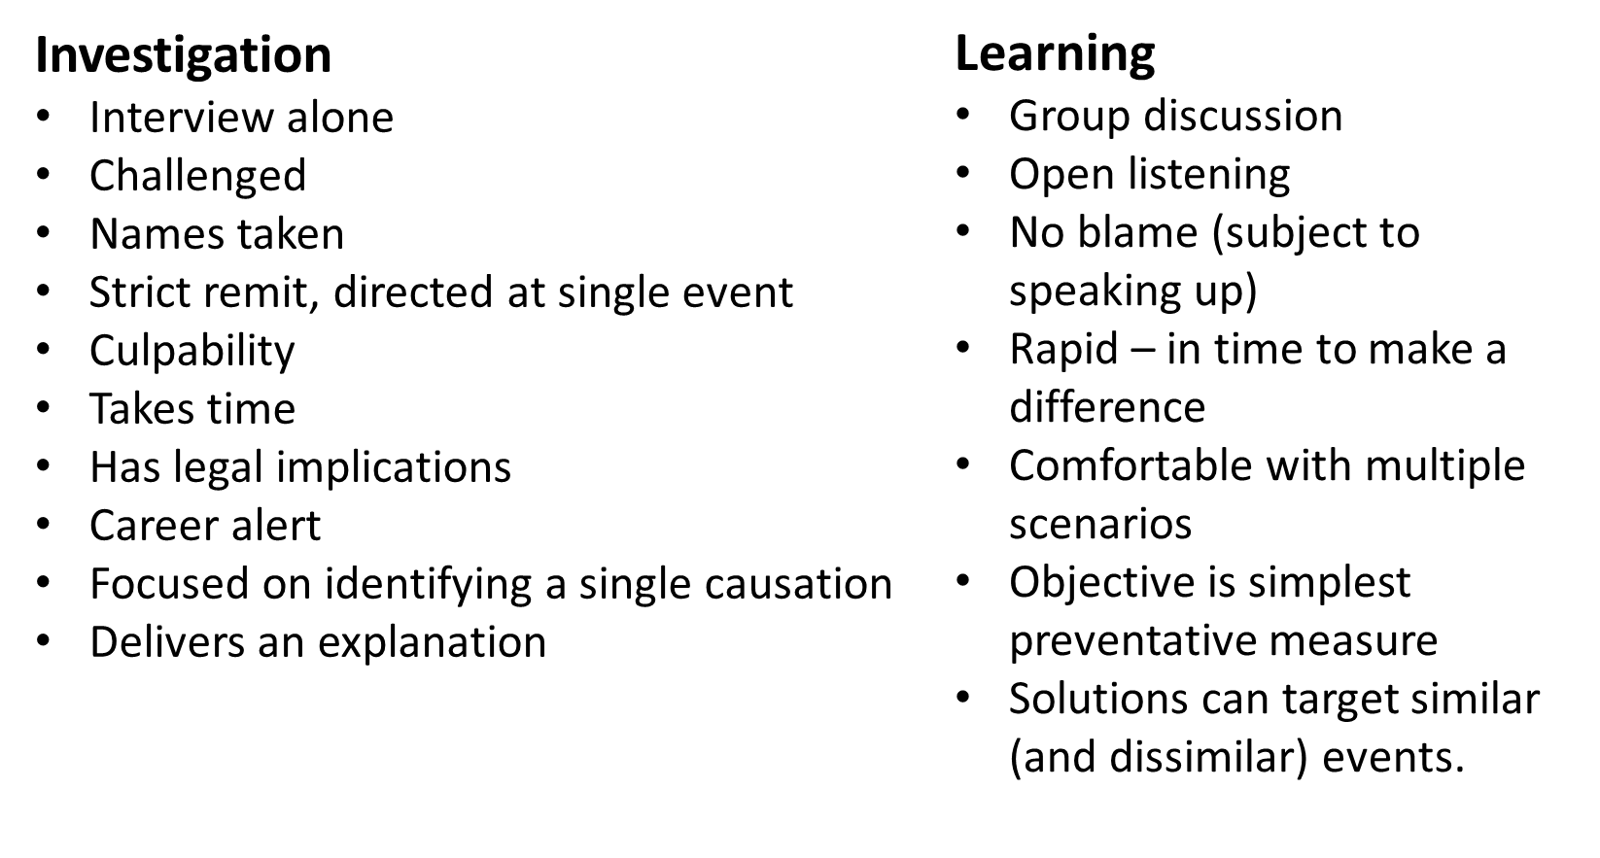

Historically investigation methods used in healthcare have tended to focus on the role of individual staff members and used terms such as “negligence” that have very negatively loaded connotations. Historically investigations are something that is “done to” the front line team, not “done with” them. This undermines the trust necessary for real learning and improvement to take place.
This situation is changing as more investigators understand the importance of organisational and systems processes and how these can led individuals to make errors. These errors are often well intentioned within a flawed system and are intended to benefit the patient and organisation not he employee, however when things go wrong it is often the lone employee who takes the blame. While the concept of “optimising errors” is understood the reality is individual healthcare workers continue to take the blame for system failures.
The lesson from other industries that control hazards is that for staff recognise that things are starting to go wrong and that they need to take action there are a number of things that must be in place. Foremost amongst these is a shared understanding:
- Shared understanding the objective of the tasks in relation to the treatment of the patient
- Shared understanding of the hazards involved
- Shared understanding how these hazards are controlled by the training, procedures, and equipment.
- Shared understanding of what the process of treatment and care should look like when the hazards are all controlled.
- Shared understanding what things indicate that the process of treatment is deviating from the intended delivery and action must be taken.
Shared understanding must be in place before the activity/treatment so that everyone knows the importance of what they are doing and what they are seeing if things go wrong. When things do go wrong there is often not time to establishing a shared understanding and consensus as events can move quickly and individual positions become polarised. Any differences in understating of the hazards, controls and indicators must be identified and addressed in advance and with time to reach agreement.
This same shared understanding becomes the basis for incident investigation and LFI because it enables everyone to understand what should have happed, what did happen and why and most importantly, what to do differently next time.
Experience in aviation and energy sectors has found that this process of establishing shared understanding has a very positive impact on team building and peer support and peer to peer monitoring. Peer to peer monitoring is a very powerful safe guard in complex operations and a key element in Crew Resource Management in aviation, oil well drilling and healthcare. To be effective peer to peer monitoring must be supporting and based on mutual trust and shared goals within the team and management, things this project aims to develop.
An important benefit of going through this process is that it is common to identify safeguards that are missing, key resources that are not always available at the point of need and procedures that are hard to carry out without error. Identifying problems such as these and rectifying them is an integral part of achieving understanding and consensus and creating the trust for LFI to function. Finding potential problems and correcting them can be one of the largest benefits of this process; in analysing and discussing the procedures and rectifying problems it will become less likely to fail and more likely to go to plan.
The phrase “setting staff up to succeed” describes this process well.
The method increasing being used in high hazard industries* and now coming into healthcare, is the graphical mapping of hazards and defences using the Bowtie Diagram. The objective of this proposal is to apply the Learning From Incidents (LFI) model of group incident reviews and hazard and defence mapping. The approach would be based on the recent model for LFI published by the Energy Institute.**
- Learning From Incidents is different to identifying root causes, it is improvement focused
- Harm is not necessary for effective LFI, it is often better select incidents in which no one was harmed taking some of the pressure out of the sessions.
- Many incident root causes include systems, procedures and communication errors and learning from these provide detailed information on how to improve systems and prevent similar incident in future.
- Repeated incidents indicate a failure to learn from incidents and this can lead to demoralisation of teams and significant costs to the organisation.

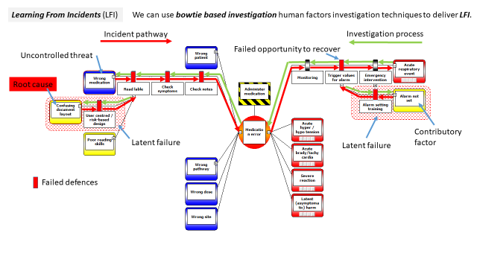

Aims
The outcomes (deliverables would be:
- The mapping of a number of incidents in bowtie / hazard defence format.
- The identification of a number of early warning indicators that an organisation or team are close to an un-planned or adverse event. While these will be specific to the event selected for analysis it is highly probably that there will be substantial read across to a number of other situations.
- Coaching on how to extract the learning and improvement opportunities from the event mapping.
- Identifying the organisational process necessary to support effective LFI; action tracking, follow up, simulation validation.
- Putting in place and effective LFI system for one discipline or department that can be the exemplar for others.
- Evaluation of the process in an “action research” (i.e. contemporaneous) format.
- In addition to these direct deliverables:
- The participating teams will learn the method and encouraged to look for other areas to apply it.
- Group training sessions on the method will be provided in participating organisations.
- The method and the outcome will be written up into a “how to” style report along with the initial evaluation experience. This report would be made freely available through Q. The intention would also be to collect further evaluation data in due course.

Who Benefits?
- The front line teams as way they work; procedures, equipment, systems, improves to prevent incidents reoccurring.
- Patients as they no longer experience the same adverse events that have occurred in the past.
- The Trust as repeated incidents reduce and LFI leads to a better workplace
- Everyone as the culture improves as staff and patients see that they are in a learning organisation.

Why does It Matter?
A failure to learn from incidents leads to repeated incidents and repeated incidents are demoralising to staff, indicate systemic failures and undermine patient trust. The key to breaking the cycle of repeated incidents is to embed a Learning From Incidents culture in which staff participate in developing lessons and raise issues early.
Where will this take place?
Predominantly on site and one of the Frimley Health Foundation Trust sites, most likely Wexham Park Hospital. One longer term objective is to develop LFI for healthcare delivery in home settings as this will be an increasing focus within the developing Integrated Care System (ICS).
Q Involvement
Other Q colleagues are invited to participate and piggy back on this project. Project material will be available to share and trail as it is developed and opportunities welcomed for knowledge sharing and dissemination.
Bid Value: £25,000
There are very likely to be additional contributions in kind, these will be de

*CIEHF White Paper, Human Factors in Barrier Management, https://www.ergonomics.org.uk/Public/Resources/Publications/Barrier_Management.aspx
The lead researcher; Rob Miles is one of the contributing authors.
**Learning From Incidents Accidents and Events: https://publishing.energyinst.org/topics/human-and-organisational-factors/learning-from-incidents,-accidents-and-events
The lead researcher; Rob Miles is one of the contributing authors.

