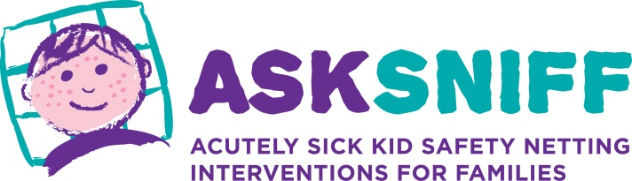

iPoorly: Child Symptom Checker
Safety netting resource for families
with children under 5 years
March 2018
The need
More children die of preventable causes, such as meningitis and sepsis, in the UK than elsewhere in Europe. Parents and professionals find it difficult to identify early signs of serious illness. Safety netting has been repeatedly recommended and evidence from the ASK SNIFF research programme shows that video-based safety netting tools are needed. Spottingthesickchild.com has been provided for professionals; the ASK SNIFF resource, developed by the UK Safety Netting Collaborative of parents and professionals, will provide a spotting the sick child resource for families. This professionally validated standardised safety netting information will help all families spot signs of serious acute childhood illness, including, but not limited to, sepsis.
We have
We now have evidenced parent and professional reviewed content for the ASK SNIFF resource, with embedded explanatory video showing real symptoms. Our next steps are to complete the video library, further develop the initial iPoorly website, converting this to a mobile ‘app’.
This information resource will help families determine when to (re)consult a healthcare professional with an acutely sick child for the six most common presenting symptoms of childhood illness (temperature, breathing difficulty, dehydration, vomiting, diarrhoea and rash). More can be added later.
Our vision
Our vision is for a safety netting resource, showing real symptoms, which is easily accessible for free by parents and professionals across multiple platforms, in all first contact settings such as emergency care, General Practice, Out-of-hours and Urgent care services, ambulance services and independently by parents. Developing this intervention through collaborative co-design, with parents and professionals, means that it is designed to meet their needs: consistent information, professionally validated, presented in a format and language they can understand. Available initially in English (with voice over for those with low levels of literacy), later translated into a wide range of other languages, more symptoms can be added in the future.

Who we are
The Safety Netting Collaborative is a collaboration between parents, professionals and third sector organisations led by Professor Monica Lakhanpaul from University College London and Associate Professor Sarah Neill from the University of Northampton and our parent panel. We are leading work in the UK on safety netting for children. ASK SNIFF is the programme of research (see below for details). We are working with academic institutions, NHS hospital and community Trusts, charities and support groups interested in progressing the development of safety netting tools for families.
The ASK SNIFF research programme
The evidence base for the ASK SNIFF resource comes from the following research projects completed within the ASK SNIFF programme of research:
- ASK SaRA: Safety-net Review & Analysis. Systematic review of the effectiveness of methods for providing information on when to seek medical care for parents of acutely sick children (2011-2012). Funded by the University of Leicester.
- ASK PIP: Parent Information Project. Qualitative exploration of parents and health care professional’s use of information sources during acute childhood illness at home (2012-2013). Funded by an NIHR Programme Grant, University of Oxford.
- ASK SID: Safety-netting Intervention Development. Identification and prioritisation of content and delivery methods for a standardised safety netting intervention (2013-2014). Funded by WellChild charity.
- ASK PETra (Phase 1): Parent Education and Training resource. Development of parent and professionally reviewed content on fever, breathing difficulties, dehydration, vomiting, diarrhoea and rash for the safety netting resource. Funded by WellChild charity.
For more information about the ASK SNIFF programme of research, including the references for publications from our work, please see the ASK SNIFF website: http://asksniff.org.uk/.
How you can help
The Safety Netting Collaborative are seeking funding for the next ASK SNIFF project, ASK PETra (phase 2); this is the crucial phase of completing the development of, and testing, the digital resource, building on all the previous work conducted by the team. ASK PETra phase 2 will comprise of the following:
- Completion of video library: Production of the remaining 40 videos of children with acute illness presenting to primary and secondary care, and well children at home, to be embedded into the tool. If available before the resource itself, these videos could be used independently enabling professionals to show parents what symptoms look like.
- Technical development: Translate the resource into a mobile phone/web based ‘app’
- Beta testing, and development of ‘How to use it’ education packages for parents and carers and health professionals.
Please contact us for further information. Associate Professor Sarah Neill Sarah.neill@northampton.ac.uk or Professor Monica Lakhanpaul m.lakhanpaul@ucl.ac.uk

