**z**

**Change Ideas – What changes did you make and what was your process?**

* Gained senior and executive support for the concept.
* Set up a project team with key stakeholders
* Gained funding for a year to employ a clinical lead for the project
* Applied and won innovation funding from both the Q community and UCLP

We designed the first PDSA for the process

1. FLC captures qualitative data through insights raised by front-line staff.
2. Issues are ‘triaged’ as FIX, IMPROVE or CHANGE. Data is logged on a digital platform.
3. Issues are resolved locally or escalated to the appropriate level.
4. Outcomes are then fed back to staff to ‘close the loop’.

We aim to pilot and embed a system of frontline learning across our 3 acute hospital sites. This concept was developed in the Nightingale hospital in London during the first COVID surge to enable staff to raise issues and get quick responses and resolution.

We decided to adapt this model of learning and listening to frontline staff in our busy acute hospitals. We feel strongly that this is a staff wellbeing project and is very relevant to our clinical teams following a very difficult year in healthcare.

The aim is that staff will receive feedback in a ‘you said we did’ format regularly and that they should begin to see things improving due to their input and improvement ideas.

**Issues raised and resolved so far**

|  |  |  |
| --- | --- | --- |
| Area | Issues raised | Resolved |
| ED Broomfield | 132 | 113 |
| Maternity unit Basildon | 82 | 56 |



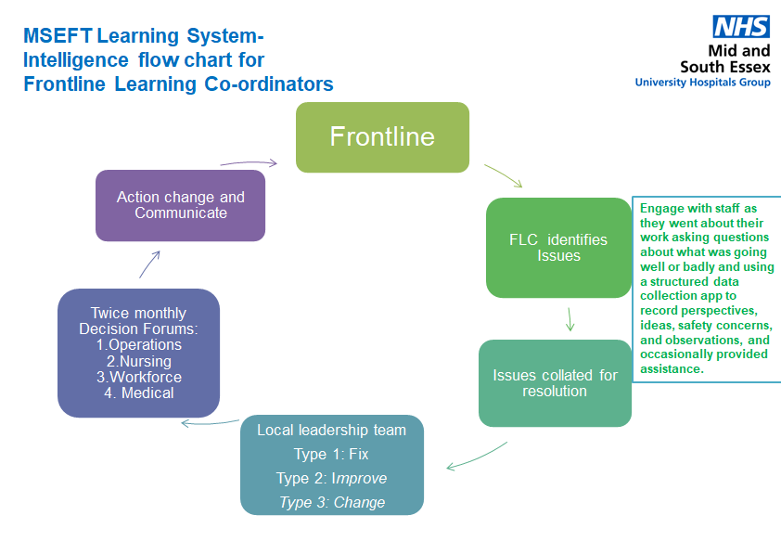

**Measures/results-What was the Impact of the changes**

**Aim and Purpose – what were you trying to achieve and why?**

**Lessons learned   
and what’s next**

* The project lead is vital to the success so secure funding for that role as a priority
* Applying for innovation grants was a great move and we have had lots of support practical and professional from engaging with UCLP and the Q community and are now part of a community of practice for this project
* One size does not fit all and we have adjusted the model to suit the needs of the clinical area to ensure success
* Capture of issues and data electronically is vital we have used ‘smartsheets’
* Feedback loop to staff is really important to build trust and faith in the project
* Commence fourth clinical area on third site in September
* We are part of learning sets with the association of groups and other key partners to share learning
* We now need to evaluate and Measure the impact of improvement

**Improvement and Change team success-2020-2021: Frontline learning coordinator project**

Project lead(s) name and role: Shevaun Mullender/Lee Ellis

Team or service involved : Improvement team

Project lead: Xxxxxxxx

**Name of project: Xxxxxxx**