Peer Assist session
February 2023

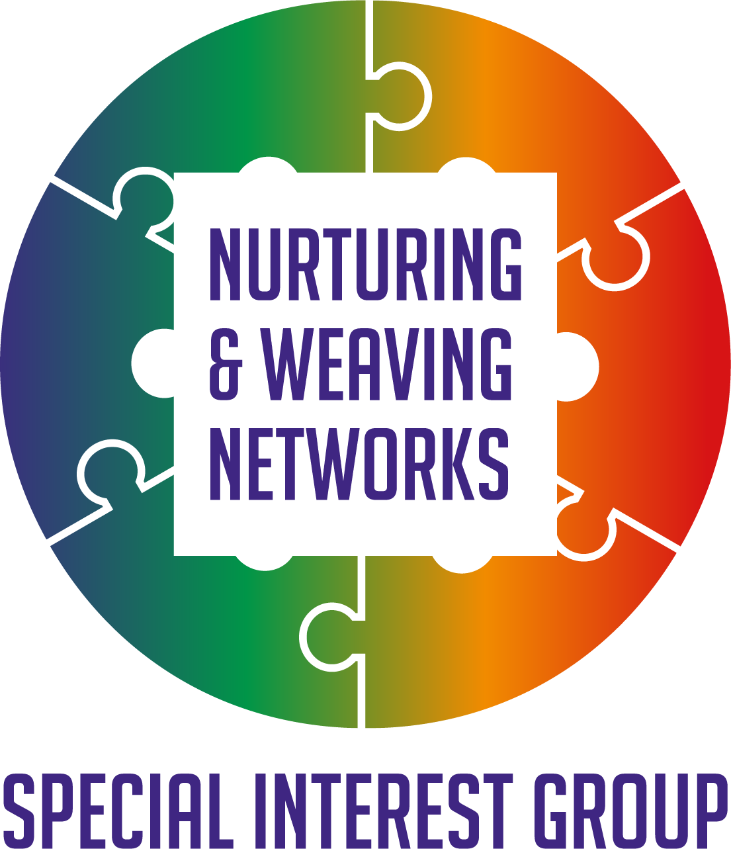

Reflections

Members of the Q Community Special Interest Group on Nurturing and weaving Networks had shared how valuable they found, when space was created to get together with peers and explore common challenges around networking in a safe space, and look for solutions together. To support this a pilot of 3 peer assist sessions was planned. The one in January used the liberating structure ‘Wise Crowds’ and in February we used Peer Assist (June Holley)
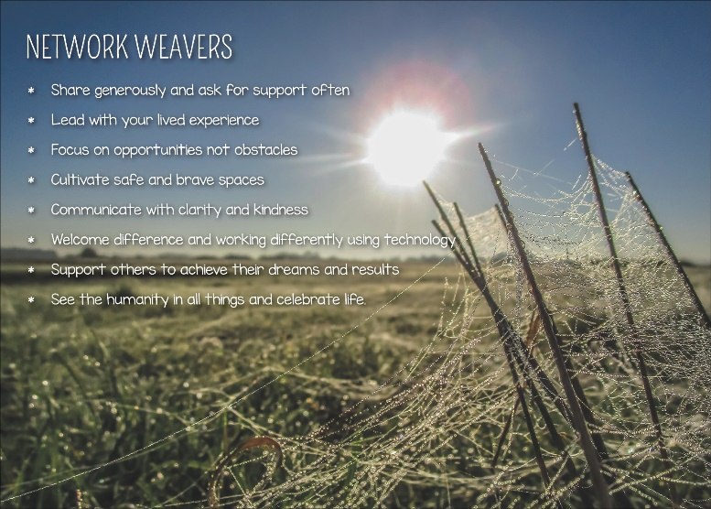
Self-care
It matters that we also are available for our own self-care as well as helping create the conditions where people can experience compassion and a culture where wellbeing is promoted. The session started with a meditation and sharing something we were looking forward to. Which included, sunnier weather, making snow angels (yep some of us still have snow!), a day trip out, connecting with new colleagues, learning something new, finding connections between different ideas and more.
Why peer assist sessions
We reflected on the value of peer assist sessions, and these are examples of what was shared.
- Regular peer assists are invaluable for practicing deep listening and resource sharing.
- To share real life examples of successes and implementing projects
- To explore and learn how to deal with power struggles within networks.
- To explore other ideas for building a community of practice around networking and network weaving.

The following offers an overview of ideas to support peer assist to date. The next session will use Troika consulting from Liberating structures

An overview of Wise Crowds (Liberating structures)

‘’ Wise Crowds make it possible to instantly engage a small or large group of people in helping one another.
You can set up a Wise Crowds consultation with one small group of four or five people or with many small groups simultaneously or, during a larger gathering, with a group as big as one hundred or more people.
Individuals, referred to as “clients,” can ask for help and get it in a short time from all the other group members. Each individual consultation taps the expertise and inventiveness of everyone in the group simultaneously.
Individuals gain more clarity and increase their capacity for self-correction and self-understanding.
Wise Crowds develop people’s ability to ask for help. They deepen inquiry and consulting skills. Supportive relationships form very quickly.
During a Wise Crowds session, the series of individual consultations makes the learning cumulative as each participant benefits not only from being a client but also from being a consultant several times in a row. Wise Crowds consultations make it easy to achieve transparency. Together, a group can outperform the expert!’’
For more information Liberating structure wise crowds

An overview of Peer Assist (June Holley)

This activity is helpful for building trust as well as seeking a fresh perspective on a challenge. You can allocate as much time as the participants are able to contribute. The timeline shared is what we used at the peer assist session; however, you can vary that to suit. It is helpful to break into smaller groups of no more than 6 to 8 people if possible. For more information Peer assist process June Holley

- Introduce yourself to each other 2min.
- One of the group members presents a challenge they have 5min.
- Those listening (The assisting group) ask clarifying questions 5min.
- The assisting group discuss the challenge and any ideas or resources they know of which may help. The person presenting the challenge listens only 10min.
- The person with the issue summaries what they have learned from listening and may try 5min.
- The Assist group reflects on the session and insights gained 5min.
- The group determines whether there are any next steps or whether they want to continue the discussion in any way 2min.
- If time allows offer other individuals/group, the opportunity to present their situation and repeat the process.

You may think this is only a little time, however, it’s amazing what can be achieved in that time as one of those who attended shared.
.
What next?
Creating this space on a regular basis for peer support would be valuable.
The next peer assist session is 6/4/23 from 4.30-5.30pm using Troika. This is the link to register Link

Find new ways to let people know when events are happening e.g., directly email.

There is a reflective session planned for 9th March 4-5.30pm looking back at the first year of the SIG and what next, revisiting how we promote and share will be added to that agenda. To register Link

How to enable contributors to contribute.

There are a variety of ways to enable people to contribute and these needs explored with those who want to engage. To be discussed on the 9th of March.

Building a community of practice around networking

Hilda is attending the Community of Practice leadership program and is keen to explore how we create a CoP around networking and invited interest at this session which was great. The next step is seeing who would be interested in being part of the design group to help the CoP get launched. Contact Hilda if you are interested hilda@cope-scotland.org

Sharing stories of success

It would be great to have different voices heard on things they have tried and what happened. This can be discussed on 9th March or send ideas to Hilda.

On 27th April 4-5.30pm our colleague Jo is sharing work they did with the Network Maturity Matrix. To register Link

Sharing resources

This link was shared by Kristin at the session to a simple article from Nonprofit quarterly on network approach to community change Link

None of us can do it alone, that is why we have each other.
We are all too aware of the many challenges and commitments on our time and the recognition that changes are needed. However, none of us alone can achieve this. The Q community offers a safe space to connect with others who want to help improve health and social care and the lives of those who receive support and offer it.
We are unlikely to find one answer which suits everyone or every situation, however, the more we learn from each other and share, the more likely we are to be able to move towards that vision of a healthier society where fewer people are impacted by inequality, to find new ways of working and service delivery that addresses the challenges we face and to be able to express that in a way that other can learn from and adopt and adapt in their situations.
You matter, what you do matters and together we can be the change. Thanks for reading and for all you do. Let us find a way through the woods, together and while we are searching, find time to rest and play also!
Hilda Campbell
Convenor Nurturing and Weaving SIG

