Document Two
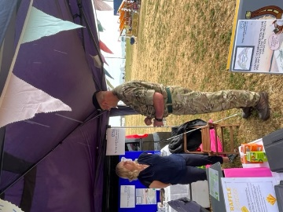
June 17th HCC Engagement at the Torbay Armed Forces Event.

Summary.
Following the suggestion from a veteran member of the HCC Veteran and Armed Forces project reference group, there was a decision to use the Torbay Veteran and Armed Forces June 17th event as an initial engagement opportunity.
“If we want to gain the in-put and guidance of people connected with the Armed Forces then we should go to where we know a significant number of them will be!”

This culminated in the successful application for a HCC stand, consisting of; Awning, exhibition boards and promotional materials staffed by members of Torbay’s Personalisation team and members of the reference group.

The Aims.
The aims of the day where to ensure any development of an HCC service was the result of collaboration and engagement with a broad spectrum of the Veteran and Armed Forces community. That the resultant new service would meet their needs as they identify them, and in a personalised way.

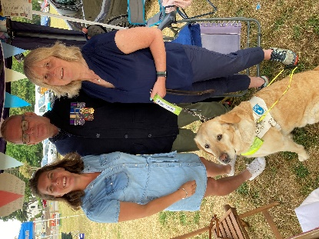
The aims of the day:
To Gather opinions and ideas.
Raise awareness of the HCC service.
Reach out to potential future HCC coaches and service users.
Ensure the views of all were captured and used in the co-design of the future model of service.

The choice of venue ensured we went out and met with the community we intended to collaborate with, Veterans, members of the Armed Forces and Reservists, family members, Veteran Charities local and national, Military Organisations and Associations.

The pitch allowed us Two elements of engagement:
Large display space for our Marketing materials to raise awareness of the HCC service.
Welcoming display space for promoting our engagement and attracting people to come and join us.

Logistical issues which needed to be overcome.
Information needed to be gathered to encourage the widest possible engagement and opportunity for opinions ideas and information.
Members of the reference group identified that the pitch needed to be comfortable and accessible to meet the needs of disabled contributors.
The HCC marketing material. Leaflets, posters, business cards where not fit for purpose and needed to be redesigned before producing in volume for use and distribution at the event.
We would need Incentives to attract people to the HCC stand.

A questionnaire was designed (See attached questionnaire). This was to include the capture of the following information:
suggestions and ideas.
Was the service required?
What the service would need to look like.
What would encourage people to use the service.
What would encourage coaches to join the service.
What would people want from the service.

Forms where produced in paper as well as electronically using MS forms. This would enable ongoing use and a wider distribution to support fuller engagement.
The HCC Plymouth research team where asked for Initial contents for the questionnaire. This was used to produce the initial questionnaire which was then taken to the reference group to alter as they saw fit. Version four (See attached HCC Veteran and Armed Forces Questionnaire) was used for the June 17th engagement event and the MS Forms. This data will continue to be gathered and built on during the engagement process.

The HCC marketing and information material including the posters for the presentation boards where redesigned through collaboration with members of the reference group and input from the wider HCC coaching members.
To attract people to the stand, posters requesting the public support to design the new service was designed and produced.
Open sided gazebo stands and tables and suitable seating was sourced.
iPad loaded with the engagement questionnaire in MS Forms was available for those preferring this option to completing the paper copies.
Forms for gathering general NHS feedback was also available.

A raffle and raffle prizes where sourced as an incentive to complete our questionnaire.
To attract people to the pitch, Free cold Drinks, and refreshments plus children’s stickers where given out.

The stand was staffed by members of TSDFT Personalisation team alongside HCC coaches including representation from our HCC coaches from a military background.
As well as attracting passers-by attending the event, the team reached out to other stands; charities, military associations, regiments, to seek their views and engage them with the questionnaire.

Thirty paper questionnaires where completed on the day with a further fourteen completed on-line during the day or shortly after.
By 1st of August Seventy-four questionnaires had been completed.

To ensure co-production, Data is currently being formatted and analysed by the HCC Veteran and Armed Forces pilot reference group.
Full data to follow. Observations so far:
Forms had been completed by Veteran and Armed Forces members, a proportion by family members from the Veteran and Armed Forces community, with a few completed by the public.
People are not aware of any existing similar service.
Veteran and Armed Forces personnel which to be matched with someone else with military experience.
There is a preference for a F2F rather than on-line service.

Outcomes from the June 17th TORBAY Veteran and Armed Forces event.
A wide cross section of the Veteran and Armed Forces community where engaged with:
Veterans.
Currently serving members of the Armed Forces.
Family members from the Armed Forces.
Representation from all arms of the military; Army, Naval and Airforce.
A range of military ranks. Previous and currently serving.
Military Charities national and local.
Military Associations and Organisations National and local.
A wide range of ages.
A good distribution across Gendas.

Awareness of the existing HCC service was raised to:
potential service users and future coaches.
Potential referring charities both national and local.
Potential referring military Organisations both national and local.

Time for Lengthy conversations with HCC representatives at the event enabled full discussion and exploration of the views and needs of the Forces Community with individuals and Organisation’s representatives. This led to a highly valuable exchange of information, understanding and perspectives and capture of additional information and insights not possible to gain from the questionnaire.
Attendance at the event has enabled relationships to be established with local individuals and Organisations leading to greater support for the HCC service and its aims of collaboration.
This has also led to contacts and individuals pledging their support and contribution to any new HCC service.

Vicki Sheen MCSP
Coordinator within Health Connect Coaching
Volunteer within the personalisation Team & Hope Programme

(A Volunteer Peer Health and Wellbeing Coaching Programme)
Torbay and South Devon NHS Foundation Trust
Email: vicki.sheen@nhs.net
Website: https://tsdft.uk/hccp
Face book: Health Connect Coaching - Torbay and South Devon | Facebook
Mobile: 07841 421111

