What is QI coaching?

Hosted by the Q Community Coaching Improvement Special Interest Group

Summary of the session
We began with a short activity in breakout rooms asking attendees “what does QI coaching mean to you?” – appreciating we all come with different insights, experiences and approaches and often the greatest learning in Q comes from a short discussion with someone you just met.
Summary of the breakout discussions from a couple of the rooms
We discussed the distinction between mentoring and coaching. Encouraging innovation and ideas, creating a creative environment and offering support. We also discussed the constraints around time, balancing priorities and cultural change.
We are interested in establishing the difference between QI Coaching and general coaching, is the coachee in a different place/circumstances which dictates what is used. How can we use QI Coaching to support QI in a system space. We think Advising, signposting and mentoring/teaching is for people that do not have QI knowledge/experience. We are keen to help staff that are already QI trained to build confidence and experience and think this is where QI Coaching fits but how can we do this?

Following the breakout rooms, the conveners shared a few examples and models for QI coaching, building on the conversations in the breakout rooms. The slides are available via the SIG, with a few shown below.
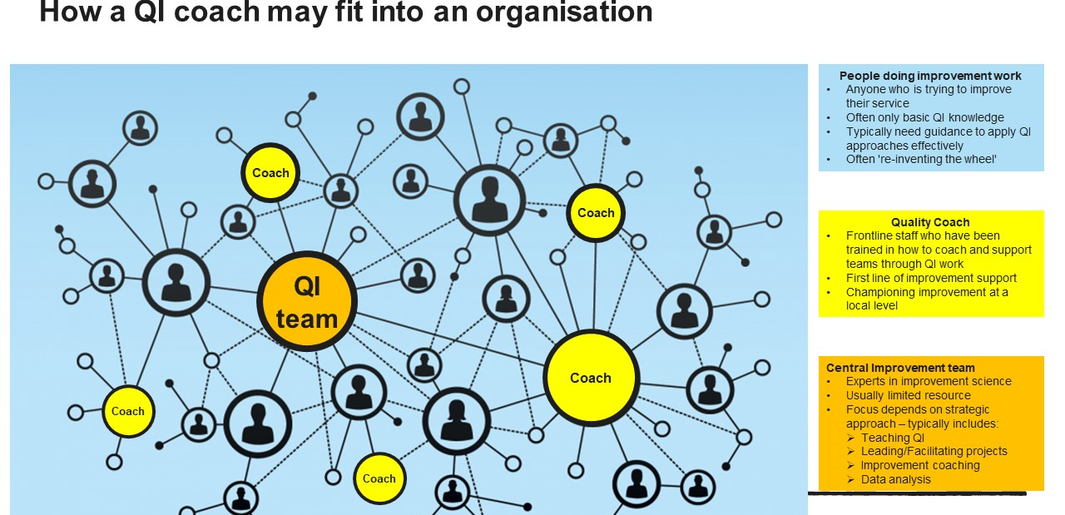
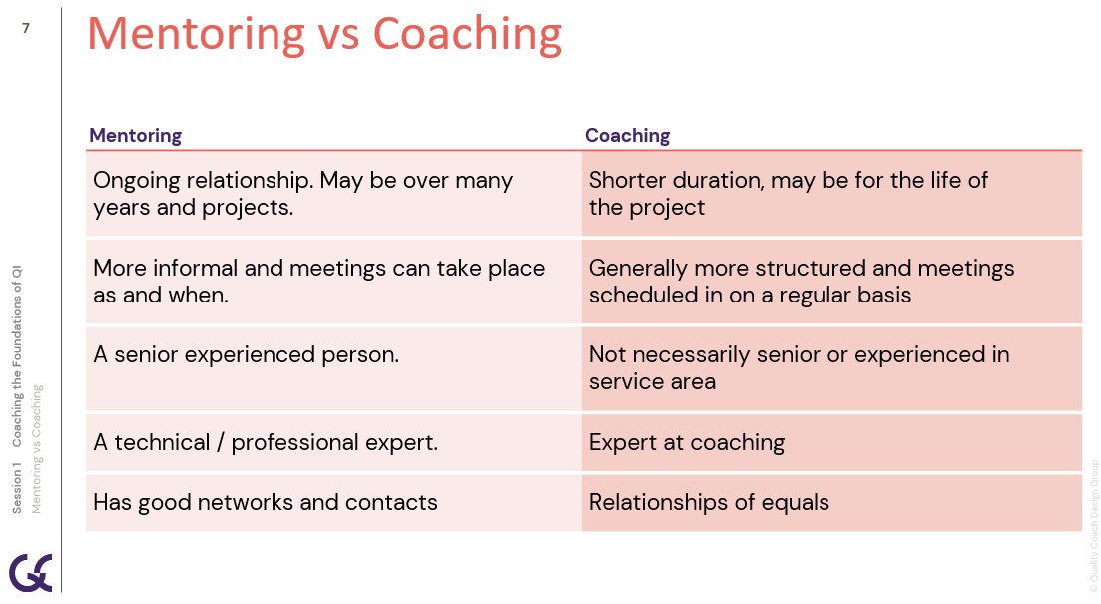
© Quality Coach Design Group, with permission
Main discussion
Following the presentation, we used MURAL for the main activity. The MURAL can be accessed here
This activity asked attendees to consider:
- What enables QI Coaching?
- What hinders it?
- What can you do to shift the dial where you work?
An example of the discussion for one of the breakout rooms (Group 4) is shown below. The factors enabling QI coaching are shown on the left and those hindering QI coaching are on the right.
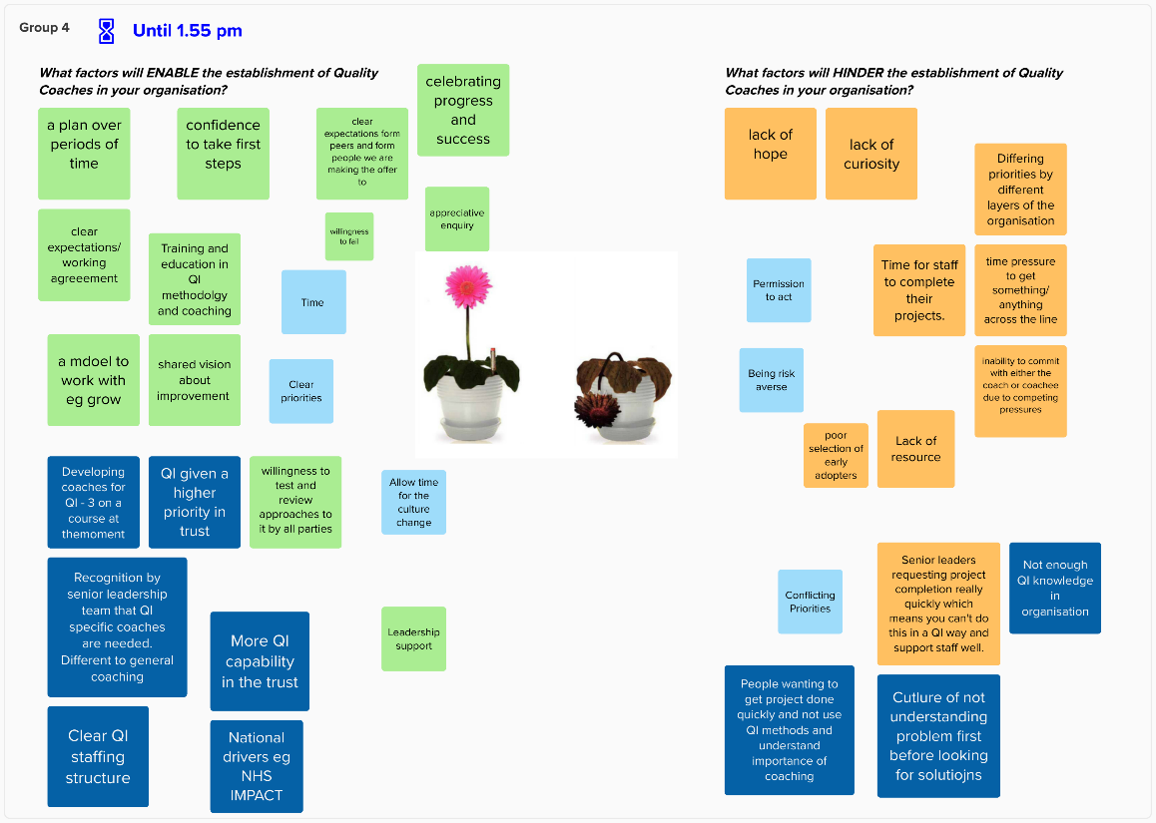
Following the activity, we closed the session using the 15% solutions structure – asking each attendee what they could begin to do in response to the insights from the session.
FAQs and discussion points raised in the chat
A few questions were raised in the chat – our answers can be found below.
- Question: [is] this is an opportunity to learn / develop group coaching?
Answer: The sessions was not an opportunity to learn about group coaching – it was more high-level focusing on the differences and similarities of coaching vs mentoring and QI coaching vs coaching development.
However, the Coaching Improvement SIG will be hosting an opportunity to practice and experience group coaching via “coaching circles” in the near future. This will begin as a small pilot in Summer 2024. Please join the SIG and keep an eye out for this opportunity soon!

- Question: We would like to use and undertake QI Coaching Development Programme and link up with each other from our different boards to peer support each other in this roll out and exploration of developing coaches.
Answer: The Quality Coach Development Programme (see the resource here for more info) will be a topic for a future workshop, given the interest from our community. It is likely that we will form a community of practice in the near future for people/organisations who are running this programme, as a means of providing peer support.
- Question: when is the next session?
Answer: Weds 17th April 12.00 – 1.30 pm, the topic is Selling the benefits of QI coaching to leaders
- Question: How can we use QI Coaching to support QI in a system space?
Answer: It’s a really interesting question. It’s very likely that we will discuss this in the proposed community of practice for faculties teaching QI coaching (mentioned above). However, for now please speak to the national Train-the-Trainer team at qi@nhselect.org.uk for the Quality Coach Development Programme and/or join the project working on systems improvement training.

Thanks to those that attended and thank you to Joriam from Q for helping to run the session and Maria from Q for promoting it across various platforms.

